LOUISE BOTHA
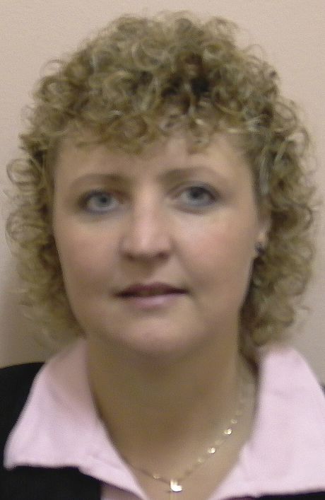

BOTHA M L: BSc (Hons), MSc, PhD (RAU)

Lecturer (April 2005 to current date)
- Natural Sciences and Curriculum
- Life Sciences and Curriculum
- Pre-service teacher training

Professional Association-membership / Lidmaatskap van Professionele Verenigings:
- Education Society of SA/ Opvoedkunde Vereniging van SA

ACADEMIC OUTPUTS / AKADEMIESE UITSETTE

Academic Journals / Akademiese tydskrifte:

1992. The effect of polyamines on ethylene synthesis during normal and
pollination-induced senescence of Petunia hybrida L. flowers. Planta 188: 478-483.

1996. Short-chain saturated fatty acids in the regulation of pollination-induced ethylene
sensitivity of Phalaenopsis flowers. Plant Physiol. 97:469-474.

1998. Effect of octanoic acid on ethylene-mediated flower induction in Dutch iris. Plant
Growth Regul. 25: 47-51.

2004. Designing an Online Tutor System for a Residential Higher Education Institution:
Madness or Miracle? International Conference on Computers in Education, Full Proceedings. p 53-58.

2005. Teaching, Learning and Assessment in Large Classes – a Reality of
Educational Change? Education as Change 9 (1):60 – 79.

2011. In-service teachers’ perspectives of pre-service teachers’ knowledge domains
in science. South African Journal of Education Vol 31:257-274.

Published Conference Proceedings / Gepubliseerde kongresbydraes:

- Designing an Online Tutor System for a Residential Higher Education Institution:
Madness or Miracle? International Conference on Computers in Education, Full
Proceedings. p 53-58. ISBN 186335570-7

2011 OBE the outcast: Beast or Beauty inScience education in South Africa? Education
Association of South Africa, Full Proceedings. p. 240-254 ISBN 978 0620 5229 7 7

Papers:

- National / Nasionaal:

2003 SAARDHE, 13th Biennial Conference. Deep and surface learning: class size and assessment. Universitiy of Stellenbosch. (July)

2006 EASA (Education Association of South Africa). The Voice of the Pre-service Teacher: Why would I want to study Biological Sciences? University of Bloemfontein, Bloemfontein, SA. (17 – 20 January).

2008 - EASA (Education Association of South Africa). Bridging the Theoretical-Practical
Science Content Knowledge Divide: Linking Tertiary Standards to Teaching Standards? Langebaan, SA. (8-10 January).

2010 - Teaching Practice Symposium: 3rd Annual Symposium: Teaching for Transformation
Science teaching for/in the 21st Century: Exploring possibilities for teacher education. Vaal Triangle Campus of North-West University (1 & 2 November).

2011 – EASA (Education Association of South Africa) - Beauty and the Beast: turning the
tide in education. OBE the outcast: Beast or Beauty inScience education in South Africa? Sun City, Gauteng, SA. (10-13 January)

2012 – EASA (Education Association of South Africa) - Criticality, Creativity and
Connections: In Pursuit of Educational Innovations: Rethinking Life Science
Teaching/Education: an innovative approach. Mpekweni Beach Resort, Port Alfred, Eastern Cape. 17 – 20 January 2012.

- International / Internasionaal:

2004 ICCE2004 (International Conference on Computers in Education), a Conference of the Asia-Pacific Society for Computers in Education (APSCE). Designing an online tutor system for a residential higher education institution: madness or miracle? Melbourne Exhibition Centre, Melbourne, Australia. (30 Nov – 3 Des).

2006 EASA/Kenton (International conference): The Teachers of Tomorrow: The Perceptions of Learning, Development and Practice of Students Following a Postgraduate Certificate in Education. Protea Hotel Wilderness Resort, Wilderness, Southern Cape (28 November - 1 December)

2009 – IAACS2009 (International Association for the Advancement for Curriculum Studies),
Stellenbosch. Rethinking Curriculum Studies. Lord Charles Hotel, Somerset West.
(7-10 September)

2009 – KENTON: (International conference) Science teacher performance in changing times.
Protea Hotel, Techno Park, Stellenbosch. (5 – 8 Nov).

2011 – Knowledge 2011 - Knowledge production and Higher Education in the 21st
Century;SAARDE & HELTASA. Mutualism between Knowledge Domains: Science Education in South African for the 21st century.V&A Waterfront, Cape Town.
(28 – 31 March)

Researchprojects / Navorsingsprojekte:

- Curriculum review for the PGCE and BEd Natural Science courses
- Evolution in Life Sciences Curriculum
- Professional Practice Schools

Professional development/ Professionele ontwikkeling

Workshop: Writing for publication prersented by The Center for Haiger and Adult Education,
Stellenbosch University. 26 – 30 January 2009.
Workshop: Postgraduate Supervision prersented by The Center for Haiger and Adult
Education, Stellenbosch University. 31 August – 2 September 2011

Co-Supervisor: Dr ML Botha; Master of Education in Educational Psychology at
Stellenbosch University.ENHANCING METACOGNITION THROUGH NATURAL SCIENCES TEACHING by Alexandra Butterfield. October 2011.

External examinations/Eksterne eksaminering

- MEd – Science education; Univeristy of the Free State (2012)
- MEd – Science education; Cape Penunsula Univeristy of technology (2011)
- BEd Hons - Science education; University of Johannesburg (2010, 2011)
- MEd – Science education; University of Johannesburg (2009, 2011)
- MEd – Science and Technology education; University of Pretoria (2006)
- PhD – Curriculum Studies; University of Johannesburg (2005)

