FAAIZ GIERDIEN
GERDIEN MF: BSc (UK) HDO (UK), PhD (Michigan State University

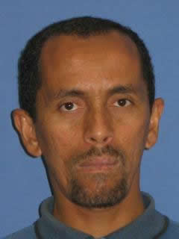
Lektor
- Wiskunde onderwyseropleiding
- Skool Wiskunde vernuwing
- Geskiedenis en Filosofie van Wiskunde as hulpmiddel in die onderrig van Wiskunde
- Kurrikulumontwikkeling

CURRICULUM VITAE

Professional Association-membership / Lidmaatskap van Professionele Verenigings:
- International Group for the Psychology of Mathematics Education (PME)
- Association of Mathematics Teacher Educators (AMTE)
- AMESA (Association for Mathematics Education / Redakteur van tydskrifte).

Member of Committees on Educational Matters / Lid van Komitee tov Onderwyssake
- President of AMESA WC (Association for Mathematics Education of South Africa, Western Cape).

ACADEMIC OUTPUTS / AKADEMIESE UITSETTE (2002-2006)

Academic Journals / Akademiese tydskrifte (selected)
2005 On the school mathematics tradition and its implications. UWCPIE, Vol. 3. (pp. 83-92)

Published Conference Proceedings (selected):
2005 Between representations, Proceedings of AMESA, Volume 2, (pp. 87-88), Kimberley
2006 From “proofs without words” to proofs that explain in secondary mathematics,Proceedings of AMESA, Volume 2, (pp. 49-55), Polokwane, 2006. (Association for Mathematics Education of South Africa) National Congress in Limpopo (July).

Papers (selected):
- National / Nasionaal
2005 What do teachers learn when they analyze a task centered on student work showing equivalent fractions? First Africa Regional Congress of ICMI (International Commission on Mathematical Instruction, Witswatersrand University (22 - 25 June)

Projects:
2006 How well do preservice teachers function when they use Excel? : A project funded by FRILT (Funds for Research and Innovation in Learning and Teaching) Stellenbosch University

OTHER / ANDER

Professional Workshops (selected):
2002 On the geometry of the multiplication table. AMESA Regional Conference, Cape Teachers Institute, Kuils River, May 13th, 2006

