CORNELIA ROUX
ROUX CD: BA (PU vir CHO) SOD, BA Honneurs, DPhil (Stell)

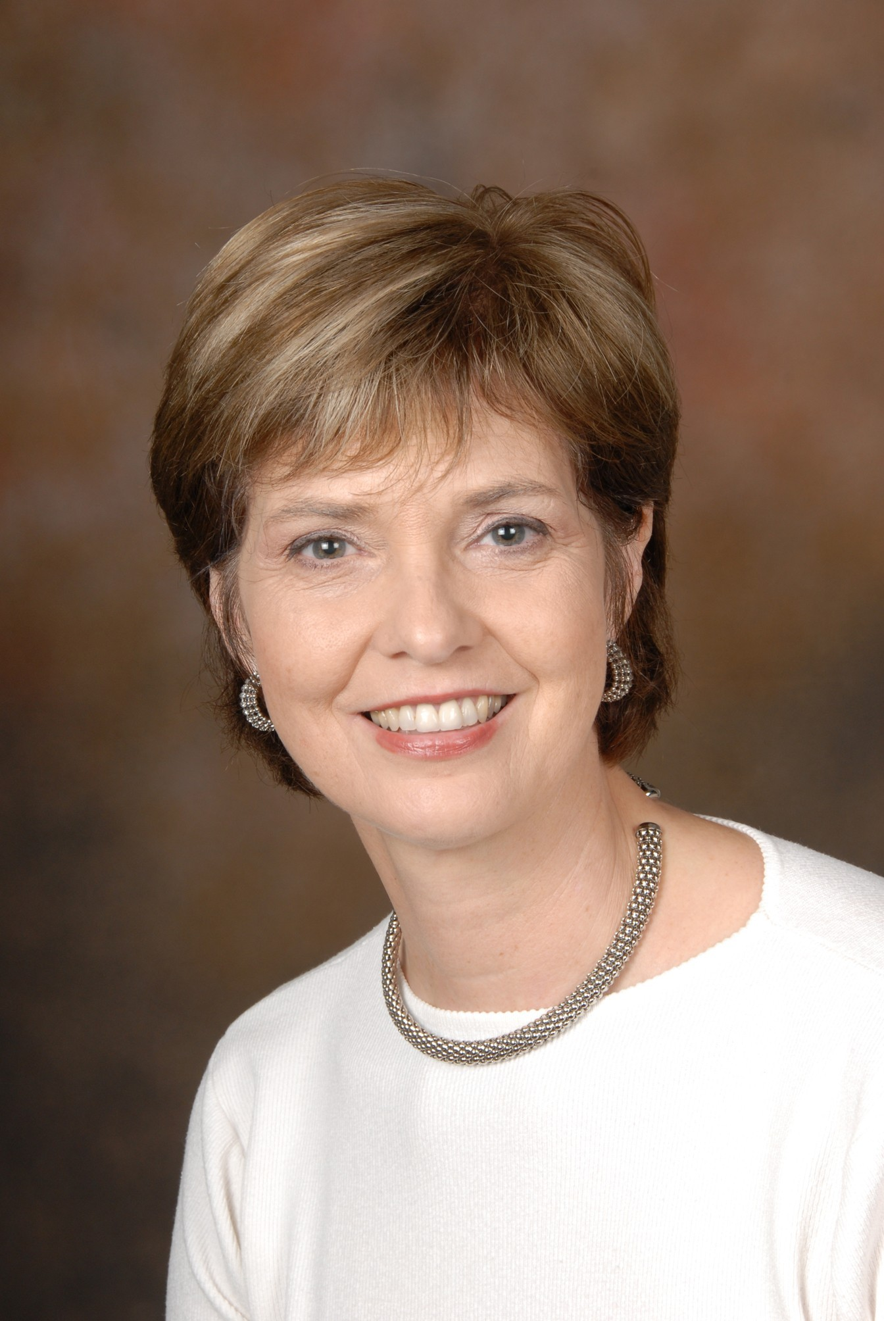
Professor
- Kurrikulumondersoek in Sosiale Konteks
- Diversiteit en Inklusiwiteit
- Multireligie en Multikulturele Onderwys
- Lewensoriëntering
- Menseregte- en waardeoriënteringsonderwys

CURRICULUM VITAE

Professional Association-membership / Lidmaatskap van Professionele Verenigings
- Full member of the International Seminar of Religious Education and Values (ISREV) Great Britain (membership by invitation only).
- Board Member of the South African Academy of Religion, (SAAR), South Africa.
- Member of the National Religious Education Society, London. Great Britain.
- Fellow of the Farmington Institute for Christian Education, University of Oxford, Great Britain.
- Member of the Association for Religious Studies in Southern Africa.
- Member of the National Association for Multireligious Education, South Africa.
- Member of the Suid Afrikaanse Akademie vir Wetenskap en Kuns, South Africa.
- Member of the South African Association for Research and Development in Higher Education (SAARDHE).

Member of Committees on Educational Matters / Lid van Komitee tov Onderwyssake
2001-2003 Member of the Standards Generating Body (SGB) of South African Qualifications Authority (SAQA).
2002-2003 Member of the Advanced Certificate in Education (ACE) task team, (National Department of Education) on Educator Skills Developing Programme: Integrating Values and Human Rights into the Curriculum.
2004 Member of the Reference Group on Religious Studies (FET-Phase) National Department of Education. Representing Institutions of Higher Education.

NRF Rating / NNS Gradering
- C 3 : Established researcher

ACADEMIC OUTPUTS / AKADEMIESE UITSETTE (2002-2006)

Academic Journals / Akademiese tydskrifte
2000 Multireligious education – an option for South Africa in the new education system British Journal of Religious Education, 22(3):173-180. (Invited to submit an article)
2001 Religion in Education in South Africa: Myth or reality? Panorama. (International Journal of Comparative Religious Education and Values), 13(1):17-26. (Invited to submit an article)
2003 Playing games with religion in education. South African Journal of Education, 23(2):130-134.
2003 (Co-author: R Ferguson) Teachers participation in facilitating beliefs and values in Life Orientation programmes. South African Journal for Education, 23(4):273-275.
2003 (Co-author: R Ferguson) Possibilities for mediation in the context of teaching and learning about religions. South African Journal for Education, 23(4):292-296.
2004 (Co-author: BD Rhodes) Identifying values in an Outcomes based Education Curriculum, South African Journal for Education. 24(1)25-30.
2004 (Co-author: R Ferguson) Teaching and learning about religions in schools: responses from a participation action research project. Journal for the Study of Religion, 17(2)5-23.
2005 Religion and peace: the role of religious education and values Panorama. (International Journal of Comparative Religious Education and Values), Vol. 16 (Winter/Summer 2005) p107 ff (Invited to submit an article)
2005 Religion in education: perceptions and practices. Scriptura (International Journal for Bible, Religion and Theology in Southern Africa), 89:293-306. ISSN 0214-1809.
2005 (Co-author: P du Preez) Religion in education: an emotive research domain. Scriptura (International Journal for Bible, Religion and Theology in Southern Africa). 89:273-282. ISSN 0214-1809.
2006 Children’s Spirituality in Social Context: A South African Example. The International Journal of Children's Spirituality, (Taylor & Francis) Vol 11(1):151-163.
2006 (Co-author P du Preez) Clarifying students' perceptions of different belief systems and values: Prerequisite for effective educational praxis. South African Journal for Higher Education 30(2):514-531.
+2006 (Co-author: P du Preez) Social Construct Perspective on an inclusive (South) Africanised Curriculum in Teacher Education (submitted)
+2006 Collaboration in teacher education through research in multicultural education (to be publisehd South African Journal for Higher Education January 2007)

Books and Chapters in Books / Boeke en hoofstukke in boeke
+2006 Children’s Spirituality in Social Context: A South African Example in Spiritual education in a divided world: Social, environmental and pedagogical perspectives on the spirituality of children and young people. (Eds. C Erricker and J Erricker). London: Taylor & Frances. (To be published 2006)
+2006 Innovative facilitation strategies for Religion Education in International Handbook on religious moral and spiritual dimensions of education (Ed. Marian de Souza) Australian Catholic University Ballarat, Kluwer Publishers. (To be published December 2006)
+2007 Interreligious Learning: Teachers’ Abilities and Didactic Challenges, (Ed. D. Pollefeyt), Interreligious Learning (Bibliotheca Ephemeridum Theologicarum Lovaniensium) Leuven, Peeters, (To be published in January 2007)

Published Conference Proceedings / Gepubliseerde kongresbydraes
2003 Facilitating belief and value systems: towards the understanding of democratic values in South Africa. Conference on Intercultural Education, Jyväskylä (Finland) UNESCO CD-Rom.

Conference papers / Kongresreferate
- National / Nasionaal
2002 Religion in Education and Democratic Values. Annual Conference Education Association of South Africa (EASA). UNISA, Pretoria. (January)
2002 Playing Games with religion. Annual Conference of Association of Religion in South Africa (ASRSA). Durban. (July)
2003 Beliefs and values systems in South African Education: A critical assessment. Annual Conference Education Association of South Africa (EASA). Stellenbosch University, Stellenbosch. (January)
2003 Religion in Education: an emotive research terrain. SAAR (South African Academy of Religion) Biennial National Conference, UNISA Pretoria (August)
2005 (Co-presenter P du Preez), Clarifying perceptions on religion, belief systems and values: prerequisite for effective educational praxis Annual Conference Education Association of South Africa (EASA). University of North-West, Potchefstroom. (January)
2005 Africanisation of the curriculum: an inclusive approach. South African Association for Research and Development in Higher Education (SAARDHE) University of Kwa-Zulu-Natal, Durban. (June)
2006 Changing perceptions of teacher-students’ on diverse belief systems: discrepancy between teaching, learning and practice. Identity Colloquim, (CEL/SOL) Univeresity of Stellenbosch (30-31 March)
2006 Holistic curriculum development – Tutorship as a support process. (Paper accepted at KENTON/EASSA Conference, Wildernis, 20 November – 1 December (Abstract accepted)

- International / Internasionaal
2003 Facilitating belief and value systems: towards the understanding of democratic values in South Africa. Conference on Intercultural Education, Jyväskylä (Finland) UNESCO:15-19 June.
2004 Religion in Education: Perception and Practices. 6th International Seminar of the International Network of Inter-religious and Inter-cultural Education, Biennial Symposium on Religious Education. Stellenbosch (South Africa) 29-31 March.
2004 Children's spirituality in social context (Theme: The spirit of the child in social and economic context). The 5th International Conference on Childrens' Spirituality. Bishop Grosseteste College, Lincoln England. (July)
2004 Religion and Peace: the role of Religious Education and Values: A South African Perspective. International Seminar on Religious Education and Values (ISREV), La Salle University, Philadelphia, U.S.A. (July)
2005 Interreligious learning: Teachers abilities and didactic challenges. International Interdisciplinary Academic Seminar Interreligious Learning. Catholic University of Leuven, Leuven Belgium. (on invitation) (January)
2006 Collaboration in teacher education through research in multicultural education. 26th Annual Seminar International Society for Teacher Education (ISTE), Stellenbosch, South Africa. 22 – 28 April.
2006 Outline of the cultural and religious context of contemporary developments in the African world. InterReligious Education and Dialogue (IRED), CHH Leeuwaarden, Netherlands. 27-29 July. (plenary on invitation)
2006 Reflective journaling in understanding religious diversity and human rights values International Seminar on Religious Education and Values (ISREV), Dreebergen, Netherlands. 30 July – 4 August.

- Posters / Plakkate
2003 The identification of values in Outcomesbased Education in co-operation with BD Rhodes. Annual Conference Education Association of South Africa (EASA). Stellenbosch. (17 January).
2006 (Co-author) Understanding human rights values in diverse education settings: Exploring pre-service students’ perceptions and reflections. KENTON/EASSA Conference, Wildernis, 20 November – 1 December

Projects / Projekte
2001-2002 Facilitating strategies of belief and value orientations in a multicultural education system. Research project with collaboration with the University of the Witwatersrand, UNITRA and the Cape Town Technicon (Wellington campus).
2004 `n Kwalitatiewe ondersoek na geselekteerde voordiens- en indiensonderwysers se persepsies rondom religie en waarde-oriënterings. Pilot Study. Research project. Department of Curriculum Studies, Stellenbosch University, Stellenbosch.
2005-2007 Understanding human rights through different belief systems: intercultural and interreligious dialogue. SANPAD-grant for an international project with 4 SA Universities, Stellenbosch, University of the Witwatersrand, Kwazulu-Natal, Western Cape and the University of Utrecht (Netherlands). (Project leader)

Project reports / Projekverslae
- Voorlopige verslag: Subkomitee A, Programbefondsing 2001/2002
- Voorlopige verslag: Subkomitee A, Programbefondsing 2004

Research reports / Navorsingsverslae

2002 Facilitating strategies of belief and value orientations in a multicultural education system. Project-leader of research project with collaboration with the University of the Witwatersrand, UNITRA and the Cape TownTechnicon (Wellington campus). 20pp.

2004 `n Kwalitatiewe ondersoek na geselekteerde voordiens- en indiensonderwysers se persepsies rondom religie en waarde-oriënterings. Department of Curriculum Studies, Stellenbosch University, Stellenbosch. 10 pp.
2005 Understanding human rights through different belief systems: intercultural and interreligious dialogue. (First Year Report – feedback from SANPAD-project management as the most outstanding report for 2005 -25 pp).

OTHER / ANDER

Guest lecturer / Gasdosent
2002 Presenter of a module in Ethics and Diversity (module for first year medical students) July, Faculty of Medical Science, Stellenbosch University. July
2003 Presenter of a module in Ethics and Diversity (module for first year medical students) July, Faculty of Medical Science, Stellenbosch University. July
2003 Presenter of a module of the Masters course (MDiv) on Religion and Education and Multi-religious Education. MTh-module in Youth Ministry, Faculty of Theology, Stellenbosch University.
2004 Presenter of a module of the BTh Course on Children's' sermons and religious development. Faculty of Theology, Stellenbosch University.
2005 Presenter of a module in Ethics and Diversity (module for first year medical students) July, Faculty of Medical Science, Stellenbosch University. July
2005 Presenter of a module on Religion, diversity and Education, Faculty of Education, Cape Town Peninsula University of Technology (CAPUT). March
2006 Presenter of a module on Religion, diversity and Education, Faculty of Education, Cape Town Peninsula University of Technology (CAPUT). March

Professional Workshops/Professionele Werkwinkels
2002 Problems and experiences in teaching multireligious education. Christian Network for Religion in Education, Pietermaritzburg, (September 2002).
2002 Multireligieuse onderrig - 'n uitdaging. Primary School Eversdal, Stellenberg, (22 October)
2006 (Co-presenters: P du Preez & A ) Life Orientation for Currciulum Advisers. FET-Band. Western Cape Department of Education. (September) Stellenbosch University.
2006 (Co-presenters: P du Preez & BD Rhodes) Religion Studies in the FET-band Teachers and Currciulum Advisers. Western Cape Department of Education. (September) Stellenbosch University

Number of current and completed Post Graduate students / Getal lopende en afgehandelde nagraadse studente
- Master students / Meestersgraadstudente: 14
- Doctoral students / Dokorale studente: 6

