LOUISE BOTHA
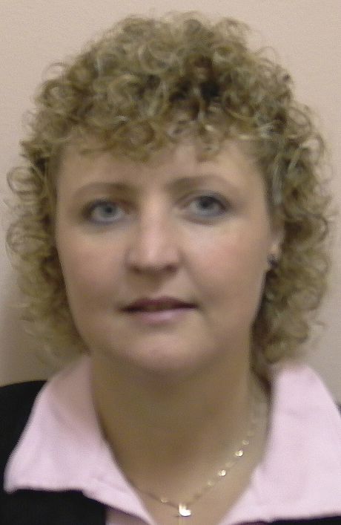
BOTHA L: BSc (Hons), MSc, PhD (RAU)
Lektor
- Natuurwetenskapsonderwys en kurrikulum
- Biologieonderwys en kurrikulum
- Multimodale leer (e-leer /WebCT)

CURRICULUM VITAE

Professional Association-membership / Lidmaatskap van Professionele Verenigings:

- Opvoedkunde Vereniging van SA / Education Society of SA

ACADEMIC OUTPUTS / AKADEMIESE UITSETTE (2002-2006)

Academic Journals / Akademiese tydskrifte:

2005 Teaching, Learning and Assessment in Large Classes – a Reality of Educational Change? Education as Change Vol 9(1) p. 60-79. SAARDHE, 13th Biennial Conference.

Published Conference Proceedings / Gepubliseerde kongresbydraes:

2004 Designing an Online Tutor System for a Residential Higher Education Institution: Madness or Miracle? International Conference on Computers in Education, Full Proceedings. p 53-58. ISBN 186335570-7

Papers:
- National / Nasionaal:

2003 Deep and surface learning: class size and assessment. SAARDHE, 13th Biennial Conference, Universitiy of Stellenbosch. (July)

2005 The Voice of the Pre-service Teacher: Why would I want to study Biological Sciences? EASA (Education Association of South Africa) University of Bleomfontein, Bloemfontein, SA. (17 – 20 January)

- International / Internasionaal:

2004 Designing an online tutor system for a residential higher education institution: madness or miracle? ICCE2004 (International Conference on Computers in Education), a Conference of the Asia-Pacific Society for Computers in Education (APSCE), Melbourne Exhibition Centre, Melbourne, Australia. (30 Nov – 3 Des).

2006 Co-writer for paper presented at EASA/Kenton international conference in December 2006: The Teachers of Tomorrow: The Perceptions of Learning, Development and Practice of Students Following a Postgraduate Certificate in Education.

Projects / Projekte:
Finlo: Curriculum review for the BEd Natural Science course

