CHRIS REDDY
REDDY CPS: BSc (Hons), M.Phil (UWC), PhD (Stell)
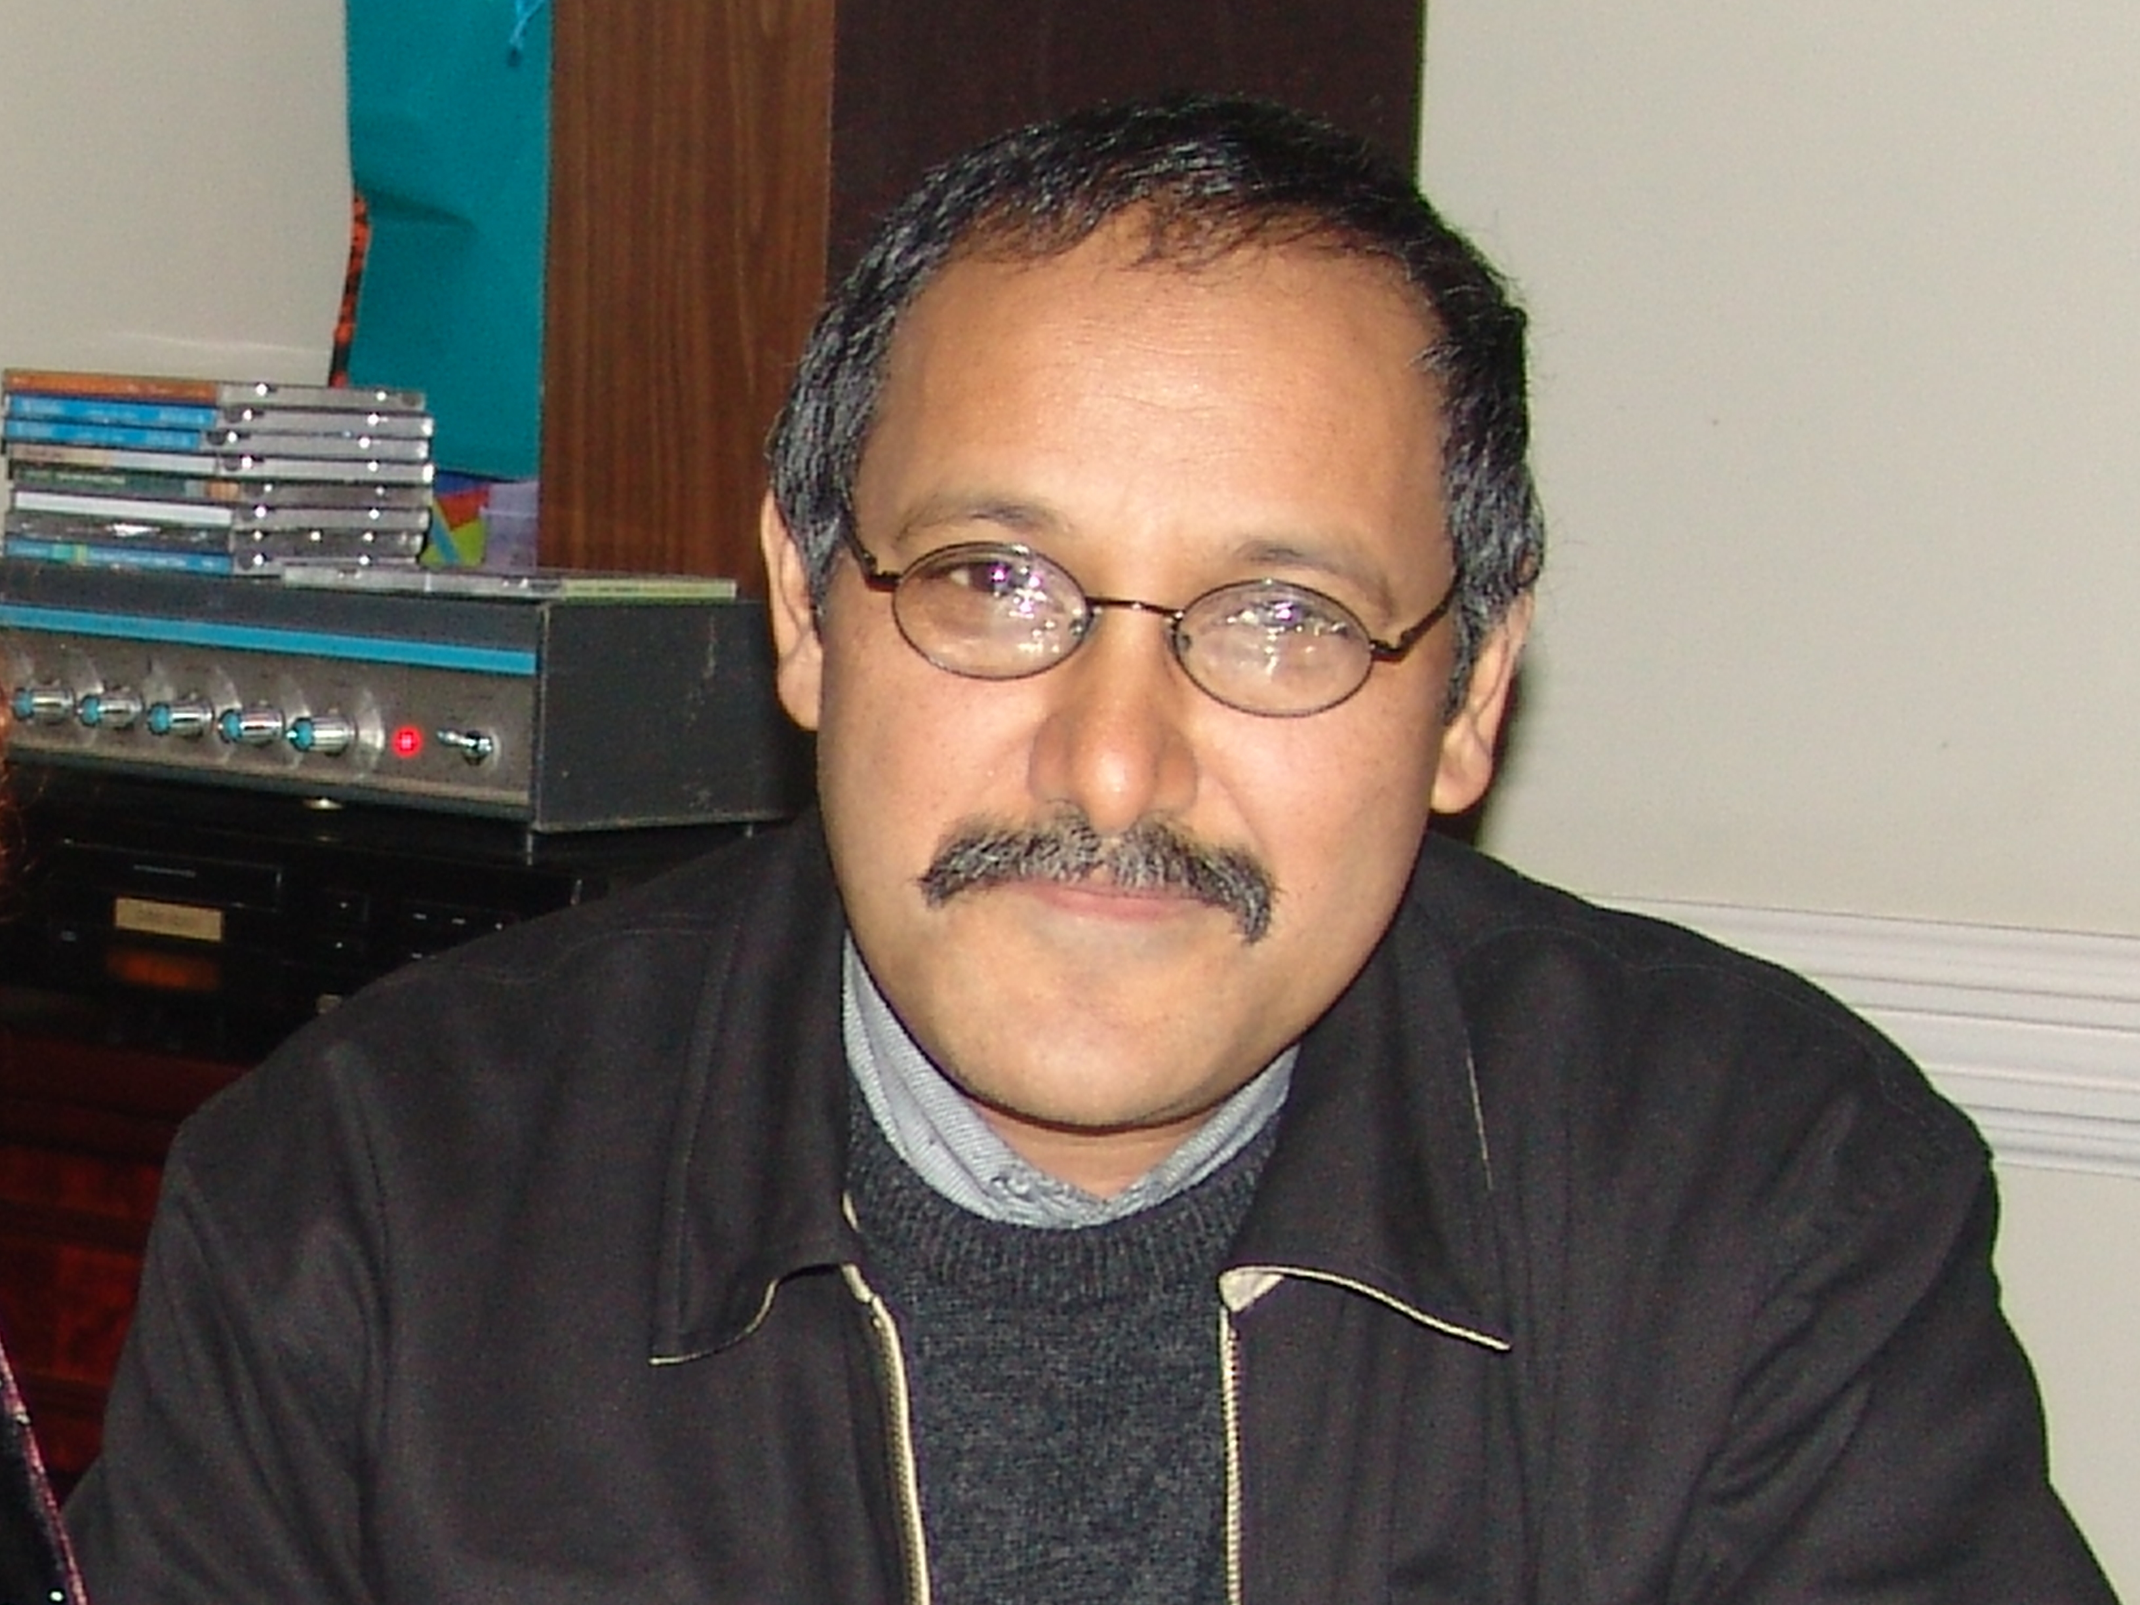

Associate Professor
- Environmental Education
- Curriculum Enquiry
- Professional studies: pre and in-service teacher education

CURRUCLUM VITAE

Professional Association-membership / Lidmaatskap van Professionele Verenigings:
- Vice President: Education Association of South Africa

Environmental Educators Association of Southern Africa
- Environmental Education Curriculum Initiative (EECI)
- Member: Education Association of South Africa (EASA)
- Member: South African Association for Research and Development in Higher Education (SARDHE).
- Founder member, Western Cape Teacher Education Research Forum with UCT, CPUT and UWC staff members 2001
- Member Curriculum Board: Western Cape Education Department

Member of Committees on Educational Matters / Lid van Komitee tov Onderwyssake
- Curriculum Board Western Cape Education Department: Teacher Education

NRF Rating / NNS Gradering
- L

ACADEMIC OUTPUTS / AKADEMIESE UITSETTE (2000-2008)

Authored books / monographs
- Le Grange Lesley and Reddy Chris (1998). Continuous Assessment: An introduction and guidelines to implementation. (Juta, Cape Town) (ISBN 0-7021-4383)
- Jenkin, N; Le Grange, L; Lotz, H; Mabunda, K; Madisakwane, K; Makou, T; Mphaphuli, E; Neluvhalani, E; Reddy, C and Robottom, I. (eds.). 2000. Educating for socio-ecological change: Case studies of changing practice in South African Tertiary Institutions. Cape Town: AUSAID. (ISBN 0-7972-0778-3).
- Reddy C and Nehuvilani E (2005). Stories of change: Action research and professional development in environmental education in the NEEP GET project. Rhodes University Environmental education and Sustainability Unit. Grahamstown. (ISBN 1-919991-08-5)

- Raven G, Reddy C and Snyder R (2005). Storyline of a project in Context: NEEP GET in the Western Cape Province. Rhodes University Environmental education and Sustainability Unit. Grahamstown. (ISBN 1-919991-12-3)

Book Chapters
- Reddy Chris (co-author) (2000). Introduction to the participatory research process. In Jenkin et al. (eds) Educating for socio-ecological change: Case studies of changing practice in South African Tertiary institutions, Ausaid, Cape Town. ISBN 0-7972-0778-3

- Reddy Chris (2000). Issue based curriculum development as a professional development process in environmental education. In Jenkin et al. (eds) Educating for socio-ecological change: Case studies of changing practice in South African Tertiary institutions, Ausaid, Cape Town. ISBN 0-7972-0778-3

- Reddy Chris (2000) School based curriculum development: Probable reality or ideological rhetoric? In educating for socio-ecological change: A resource pack for developing and reviewing environmental education in universities and colleges of education in South Africa. Howick: AUSAID

- Schreuder D, Le Grange l and Reddy C (2002). Environmental education as processes of change and reconstruction: The Science and Sustainabilty project. In Tilburry D, Stevenson R, Fein J and Schreuder D (Eds), Education and Sustainability: Responding to the Global Challenge. Commission on Education and communication, IUCN, Gland Switzerland.

- Schreuder, DR; Reddy, CPS &. Le Grange, L 2000. Science and sustainability: Alternative understandings of education and sustainability. In Jarnet, A et al (eds.), The Future of Environmental Education in a Postmodern World? Canada: Yukon College. pp. 170-174. (ISBN: 0-9694150-2-8).

- Reddy C (2004). Assessment Principles and Approaches. In Fraser, W and Maree, J (EDS) OBE Assessment. Johannesburg: Heinemann

- Reddy C (2004). Democracy and In-service processes for teachers: A debate about professional teacher development programmes. In Waghid Y and Le Grange L (Eds), Imaginaries on Democratic Education and Change. Pretoria: Southern African Association for Research and Development in Higher Education.

- Reddy C, Du Toit G & Du Toit E (2008). OBE and Assessment Principles and Approaches. In Fraser, W and Maree, J (EDS) OBE Assessment. Johannesburg: Heinemann

ACCREDITED AND REFEREED ACADEMIC JOURNALS
(i)International
- Le Grange L and Reddy C (1997). Outcomes Based Education and Environmental Education in South Africa : A marriage made in heaven ? Southern African Journal of Environmental Education (17) 1997.
- Reddy C and Schreuder D (2004). Scholarship in environmental education in a marketised setting Environmental Education Research, Vol 10(3), pp29
- Dillon J, Ketlhoilwe MJ, Ramsharup P & Reddy C (2005). Designing research in Environmental Education: Curriculum Policy construction, conceptualisation and Implementation as exemplified by Southern African examples. Southern African Journal of Environmental Education Vol 22, 2005.
- Le Grange L and Reddy C (2007). Environments of learning and learning environments. Southern African Journal of Environmental Education Vol 24, 2007.

(ii) National
- Reddy, Chris and Le Grange, Lesley 1996. Continuous evaluation: Friend or Foe? Spectrum, 34(2): 18-20.
- Le Grange, Lesley; Schreuder, Danie and Reddy, Chris 1997. Sustainability in Curriculum 2005. Enviroteach (3): 9-11.
- Schreuder, Danie; Le Grange, Lesley and Reddy, Chris 1998. Sustainability as a unifying theme in biology curricula. Spectrum, 36(1), 4-7.
- Schreuder D, Le Grange L and Reddy C (1999). Science and Sustainability: Exploring new perspectives in environmental education. SA Journal of Education, Vol 19 (2), pp127-130.
- Le Grange L and Reddy C (2000). Introducing teachers to Outcomes Based education and Environmental Education. A Western Cape Case study.
SA Journal of Education, Vol 20 (1)
- Reddy C and Menkveldt H (2000). Teaching students to reflect: a preliminary study of reflective practice in a University environment. SA Journal of Higher Education Vol 14 (3)
- Reddy C, Le Grange L & Waghid Y (2004). Environment as community.
SA Journal of Higher Education, Vol 18(1).
- Le Grange and Reddy (2007). Environments of Learning and learning environments. Southern African Journal of Environmental Education and Ethics Vol
- Reddy C, Menkveld H & Bitzer E (2008). Reviewing practices for practicum: an institutional survey. South African Review of Education, Vol 14, (1&2).
- Kunkwenzu E and Reddy C (2008) Using grounded theory to understand teacher socialisation: A research experience. Education as Change, Vol 12 (1)

Conference Proceedings
- Le Grange, Lesley & Reddy, Chris. 1998. Introducing outcomes-based education to teachers using environmental education materials and case studies. Proceedings of a colloquium on environmental education research, 3-4. Pretoria: HSRC.

- Reddy C (1999) Opportunities for initial teacher education in a changing policy environment: In Smit M & Jordaan A (compilers). Curriculum 2005: Rhetoric and Reality. Proceedings of the National Didactics/Learning Area Symposium, pp 74-80. Stellenbosch: University of Stellenbosch.

- Reddy C (2000) Can devolution of power enable transformation in schools? Proceedings of the Democratic Transformation of Education in South Africa Conference, Johannesburg: Konrad Adenauer Foundation.

Popular articles

- Reddy C (2002). The seashore in service of the environment. Phycological Society of Southern Africa, Newsletter 52.
- Reddy C (2008) Bringing the environment and biodiversity into the curriculum. Veld and Flora Magazine September 2008, Vol 93(4)

Conference presentations

National
- Paper: Looking back to forge ahead: reflective practice as a professional development process. Paper presented at Education Association of SA conference, Boland College January 1999.
- Paper: Opportunities for inititial teacher education in a changing policy environment: National Didactics Association of South Africa symposium, Stellenbosch, September 1999.
- Paper: African rennaissance: A new dawn for teacher education? Paper presented at Education Association of SA conference, Bloemfontein January 2000.
- Paper: Teacher professionalism: a cycle of poverty? Kenton Education Association conference, Sea View, Port Elizabeth. October 2000.
- Paper: Co-operation on National and international levels: reporting on a joint research project on continuous assessment. (With Hannie Menkveldt). Paper presented at Education Association of SA Conference UPE January 2001.
- Paper. Teacher responses to systemic policy changes: Implications for policy and practice. South African Education Association, Conference University of Pretoria, January 2002.
- Paper. Inservice teacher education and professional development: Exploring options in times of transformation. South African Education Association Conference Stellenbosch University, January 2003.
- Paper: Theory practice relationships: A local perspective on a perennial debate. S. African Association for Research and Development in Higher Education conference Stellenbosch University, July 2003.
- Paper: Resourced based in-service programmes as a professional development process: some initial experiences. Education Association of South Africa conference, Potchefstroom, 17-19 January 2005

Paper: Practicum in teacher education: an institutional survey. Education Association of South Africa conference, Bloemfontein, 18-20 January 2006
- Paper: Curriculum Development in a higher education context. Kenton-EASA conference, Novemebr 2006, Wilderness.

International
- Paper: Issue based curriculum development as a professional development process in environmental education, EEASA conference, September 1999, Grahamstown
- Paper: School-based curriculum development: possibility or pipe dream? EEASA conference, September 1999, Grahamstown
- Paper: Can devolution of power enable transformation in schools? Konrad Adenauer foundation conference, Democracy and Education, Stellenbosch, September 2000.
- Paper.Action Research and Reflective Peractice: Catalysts for professional development processes? Action Learning, Action research and Process Management conference, 21-24 September 2003, University of Pretoria
- Paper:Teacher professionalism and professional development: a philosophical enquiry. International Network of Philosophers of Education, Universidad Completense, Madrid, Spain, August 2004.
- Paper: Water quality monitoring as a curriculum process in environmental education. Presentation at the 8th International Invitational Seminar on Environmental and Health Education. Grahamstown: Rhodes University. 15-17 March, 2005.
- Paper: Teachers partnerships as practitioner research: Practitioner research and action research conference, 4-7 November 2005, Utrecht, Holland.
- Paper: Practicum in Teacher Education: Exploring challenges and responsibilities. International Society for Teacher Education conference, Stellenbosch, 24-27 April 2006.
- Paper Research in contexts: exploring teacher development processes in EE. Invitational seminar: Switzerland, March 2007
- Supporting EE implementation in context: inset case studies. World Environmental Education Conference Durban 2007
- Supporting EE implementation through collaborative partnerships: INSET case studies. American Education Research Association conference, New York 2008.

Number of current and completed Post Graduate students / Getal lopende en afgehandelde nagraadse studente:

Year | Candidate | Institution | Degree | My involvement | Current Status
2003 | Chris Mertz | Stellenbosch University | PhD | Associate supervisor | Completed
2005 | Petto Ferreira | Stellenbosch  University | PhD | Associate supervisor | Completed
2005 | Heleen De Vries | Stellenbosch University | MEd:  Full thesis | Supervisor | Completed
2005 | Neal Petersen | Stellenbosch University | MPhil: Ed  Leadership | Supervisor | Completed
2006 | Hestelle Melville | Stellenbosch University | M.Ed: Environmental Education | Supervisor | Completed
2006 | Zorina Dharsey | Stellenbosch University | M.Ed:  Curriculum Studies | Supervisor | Completed  (Cum Laude)
2007 | Andre Rowan | Stellenbosch University | M.Ed  Full thesis | Supervisor | Completed
2007 | Esthery Kunkwenzu | Stellenbosch University | PhD | Supervisor | Completed
2008 | Akeda Isaacs | Stellenbosch University | MEd  Full thesis | Supervisor | In progress
2008 | Jeffrey Lombard | Stellenbosch University | PhD | Supervisor | In progress
Reviewer - Editorial work / Keurder - Redakteurswerk
- Reviewer : Canadian Journal of Environmental Education
- Reviewer: Southern African Journal of Research and development in Higher Education
- Reviewer : Perspectives in Edcuation
- Reviewer : Per Linguam
- Reviewer : Acta Academica
- Reviewer: Africa Education Review
- Reviewer: South African Journal of Education
- Reviewer: Environmental Education Review
- Consultant editor: Trans Curriculum International Journal

