

Minnaar
Tour & Shuttle

Minnaar Tours” is an experienced and reputable Tour Operator who is committed to the promotion of South Africa as a preferred holiday destination with the core service value of creating innovative, exclusive and inspirational tour experiences on the African continent.
Our vision is become one of South Africa’s leading and privately owned tour operator- and management companies by means of service excellence and innovative products in order to maximise value to our clients.
Our staff is highly trained and experienced, able to arrange all aspects of travel. We pride ourselves on our attention to detail and high standard of personal service

TRANSFERS
FROM CAPE TOWN AIRPORT TO | 1 PAX | 2 PAX | 3 PAX | 4 PAX | 5 PAX | 6 PAX | 7 PAX
1. STELLENBOSCH | R160 | R190 | R220 | 250 | R280 | 310 | 340
2. CAPE TOWN CITY | R140 | R170 | R200 | R230 | R260 | R290 | 310
FROM STELLENBOSCH TO | 1 PAX | 2 PAX | 3 PAX | 4 PAX | 5 PAX | 6 PAX | 7 PAX
1. CAPE TOWN CITY | R200 | R240 | 280 | 320 | 360 | 400 | 440
2. SOMERSET WEST | R140 | R170 | R200 | R230 | R260 | R290 | 320
DAILY TRANSFERS
FROM ACCOMODATION TO | 1 PAX | 2 PAX | 3 PAX | 4 PAX | 5 PAX | 6 PAX | 7 PAX
1. CONFERENCE VENUE | R40 | R60 | R80 | 100 | R120 | 140 | 160
PLEASE NOTE:
- Transfers as quoted above is all one direction
- Cost to any other destination not listed is available on request.

CONTACT US FOR A BOOKING:

minnaartours@yahoo.com
or
sonia.stellenboschshuttle@gmail.com

Emergency number: 083 403 0956 (John or Sonia)




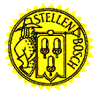
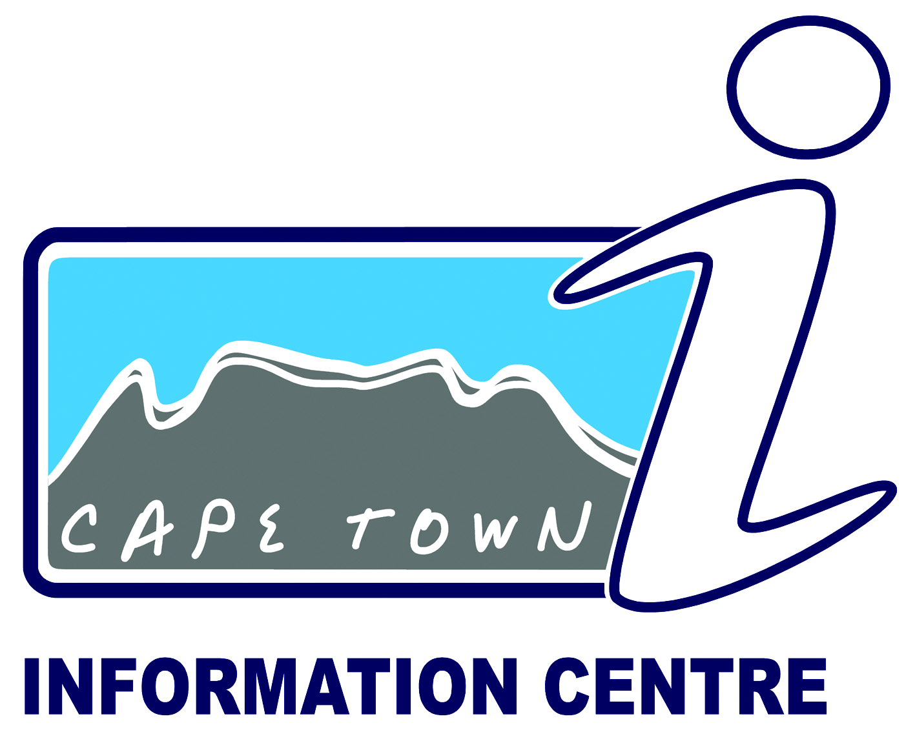
Please call the above number in the case of any flight details or any other queries

